**EWB-Cornell Website Info:**

Please refer to this document for information about what is needed to keep the website up-to-date each semester! Although you are welcome and encouraged to work on/improve the current website, please do so prioritizing ease of editing content for each semester, for people with or without web dev experience. Historically, we have found complicated websites only one or two people understand become difficult to pass along to new members, and we believe updated content is more important for our purposes than a “fancy” website.

This readme will walk through each section, then give a to-do list for the semester to keep each section up-to-date.

-Clare Snyder (cds238), Spring 2019

**Header/Nav Bar**

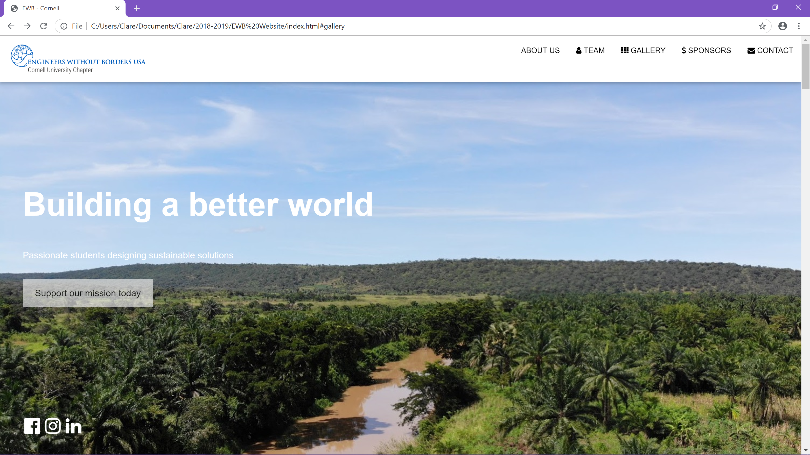

Use the sections headed with these comments:

<!-- Navbar (sit on top) -->

<!-- Sidebar on small screens when clicking the menu icon -->

to edit the navigation bar. Make sure any edits you make to one of these sections, you make to the other. For instance, if you add a link to a new section, please do so for both top nav bar and sidebar. These serve as adaptive nav bars (sidebar is for small screens, like a phone screen). Please refer to <https://www.w3schools.com/html/html_links.asp> to learn how to link. Note the format of the bar, with all capitalization and an icon for all parts of the website (except the ABOUT US directly below the header image). ­

To edit the header, refer to the section headed with this comment:

<!-- Header with full-height image -->

Choose a large image for the header, which will be pleasing to see as pictured above – this picture should not be pixelated and should highlight our work or frame the text well.

**About Us**

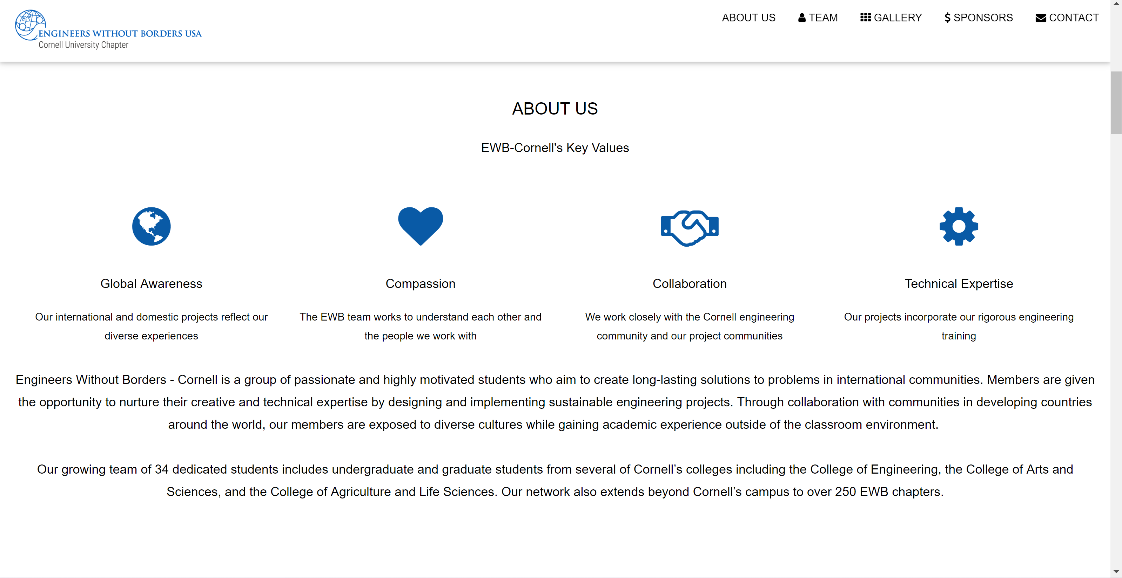

This area is under the comment:

<!-- About Section -->

And can be accessed through the navbar with the internal link

#about

This section is highly customizable – the text can easily be edited within the p tags without creating any problems with the rest of the website. The icons can easily be changed for others using the fontawesome icons linked here: <https://www.w3schools.com/icons/fontawesome_icons_webapp.asp>

The color of these icons follows the color dictated by the EWB national chapter style guides. <https://issuu.com/ewb-usa/docs/ewb11-021_brandguide_rd10>

**Our Projects**

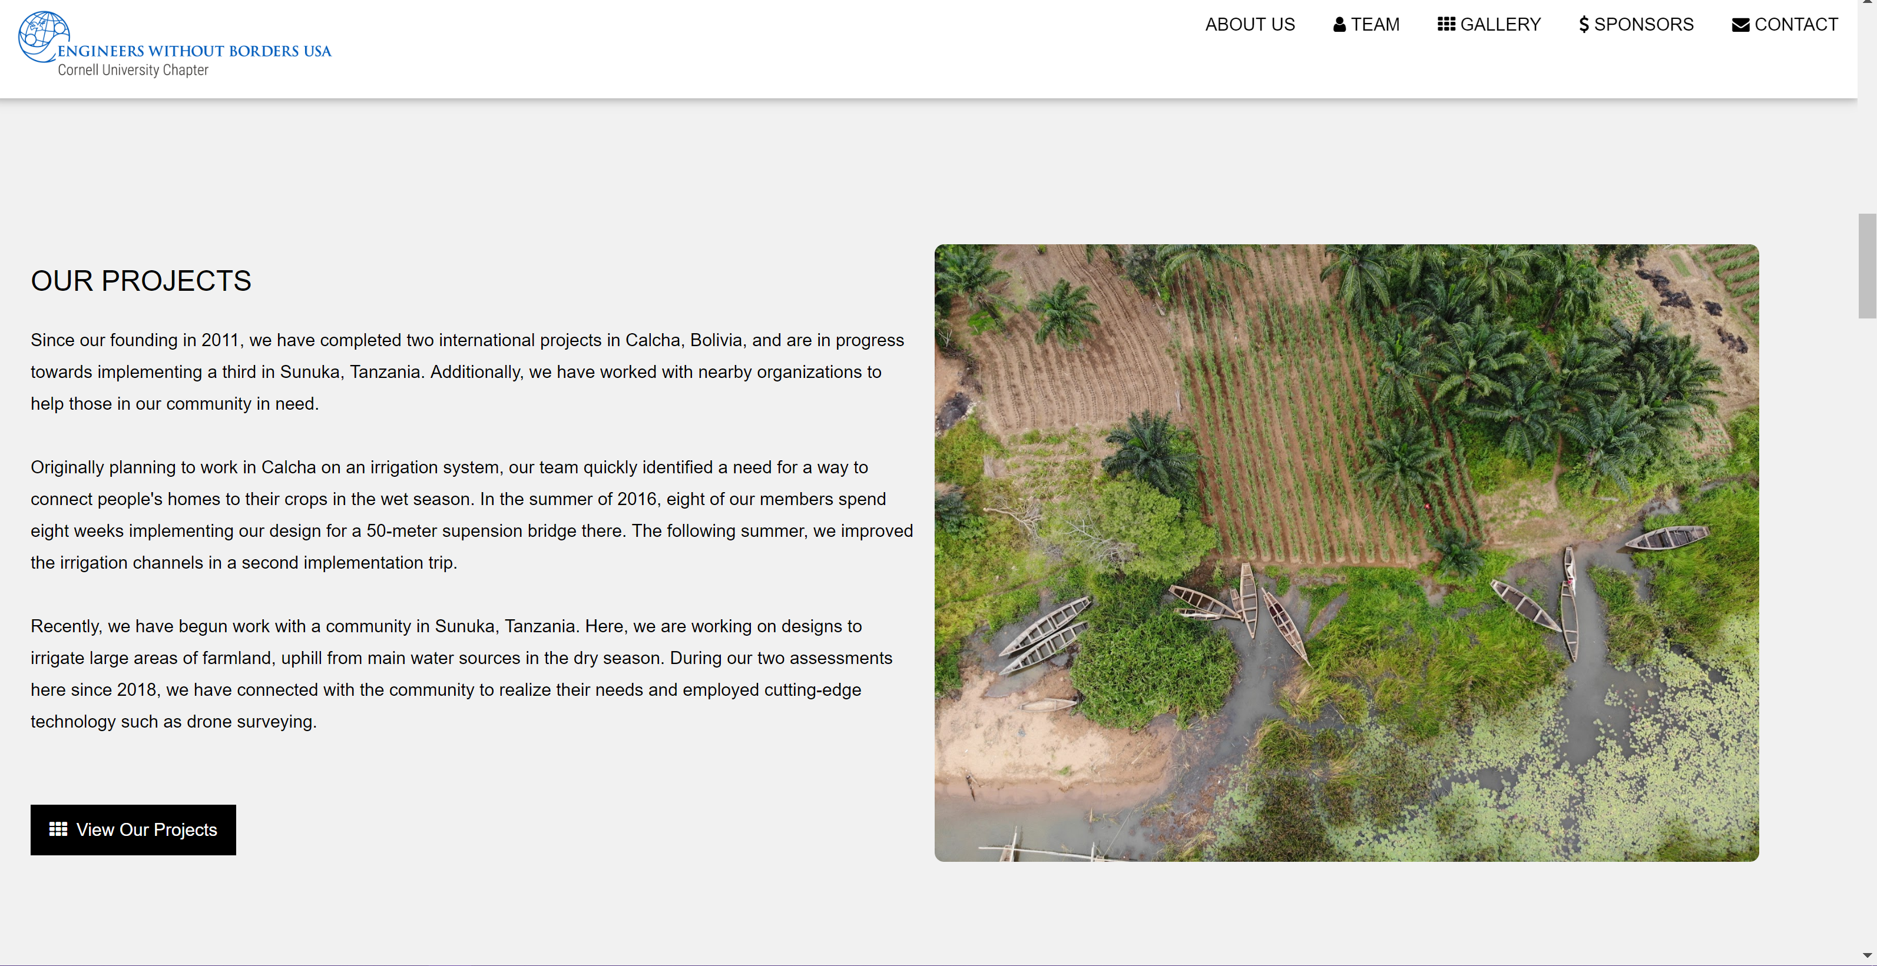

The first “OUR PROJECTS” section is under the comment

<!-- Promo Section --->

And it is not linked through the nav bar. Again, this section can easily be edited, particularly the image and text (in the <p> tag). The black button links further down the website to a gallery of images and link to our media.

**The Team**

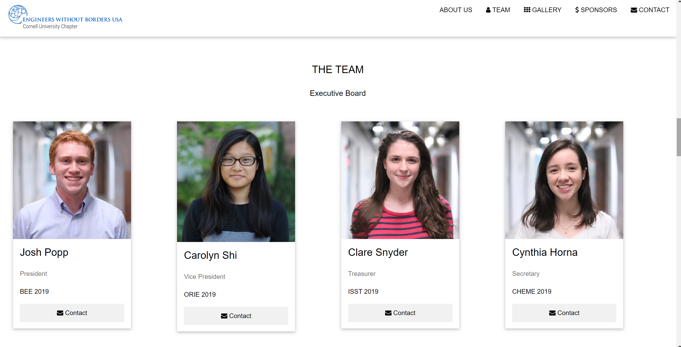

There are two places where the team info is present. One is the main page (index.html), and the other is team.html, which is accessed from the main page by a link in the team section.

The code for these sections is essentially identical, and any edits to one should be made to the other. On the main page, only eboard and the full team photo are shown, on the larger page all members are pictured, as well as the old team photos from past years.

In the index.html page, the comment header is

<!-- Team Section -->

The pictures and member bio is easy to change by filling in the red text with personalized info for a new member (all headshots should be in the Headshots folder within Images):

<div class="w3-col l3 m3 w3-margin-bottom">

<div class="w3-card" style="width:75%">

<img src="Images/Headshots/photo_name.jpg" alt="Name" style="width:100%">

<div class="w3-container">

<h3>First Name Last Name</h3>

<p class="w3-opacity">Title (optional)</p>

<p>Major Year</p>

<p><button class="w3-button w3-light-grey w3-block"><a href="mailto:netid@cornell.edu" style="text-decoration: none;"><i class="fa fa-envelope"></i> Contact</a></button></p>

</div>

</div>

</div>

**Stats Bar**

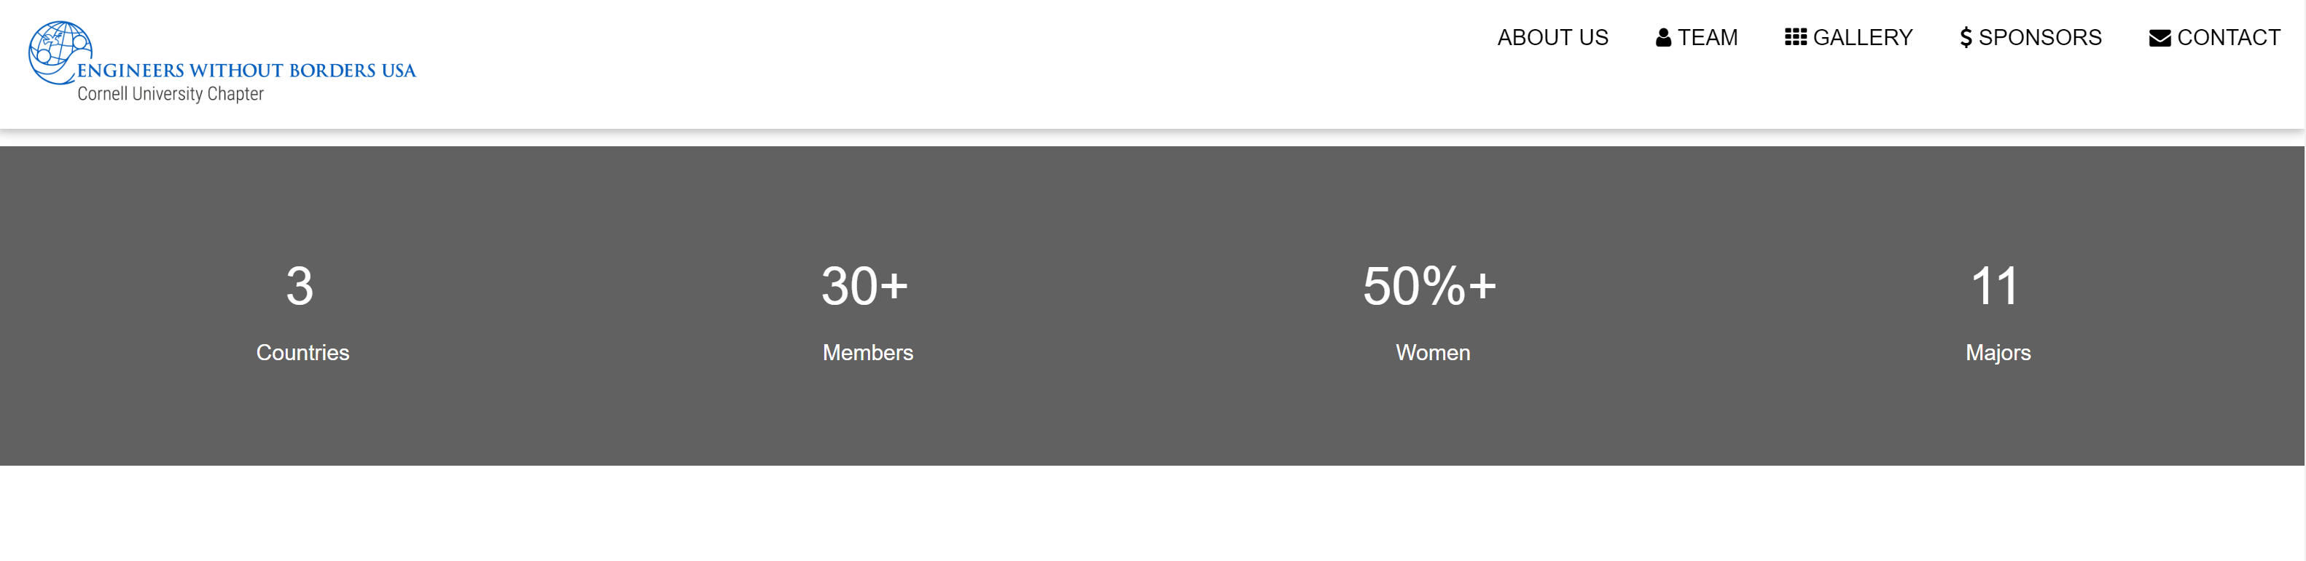

This small section serves as a quick visual of EWB Stats. It is under the

<!-- Promo Section "Statistics" -->

comment header. The numbers and values can easily be adjusted within the span tags.

**Our Work**

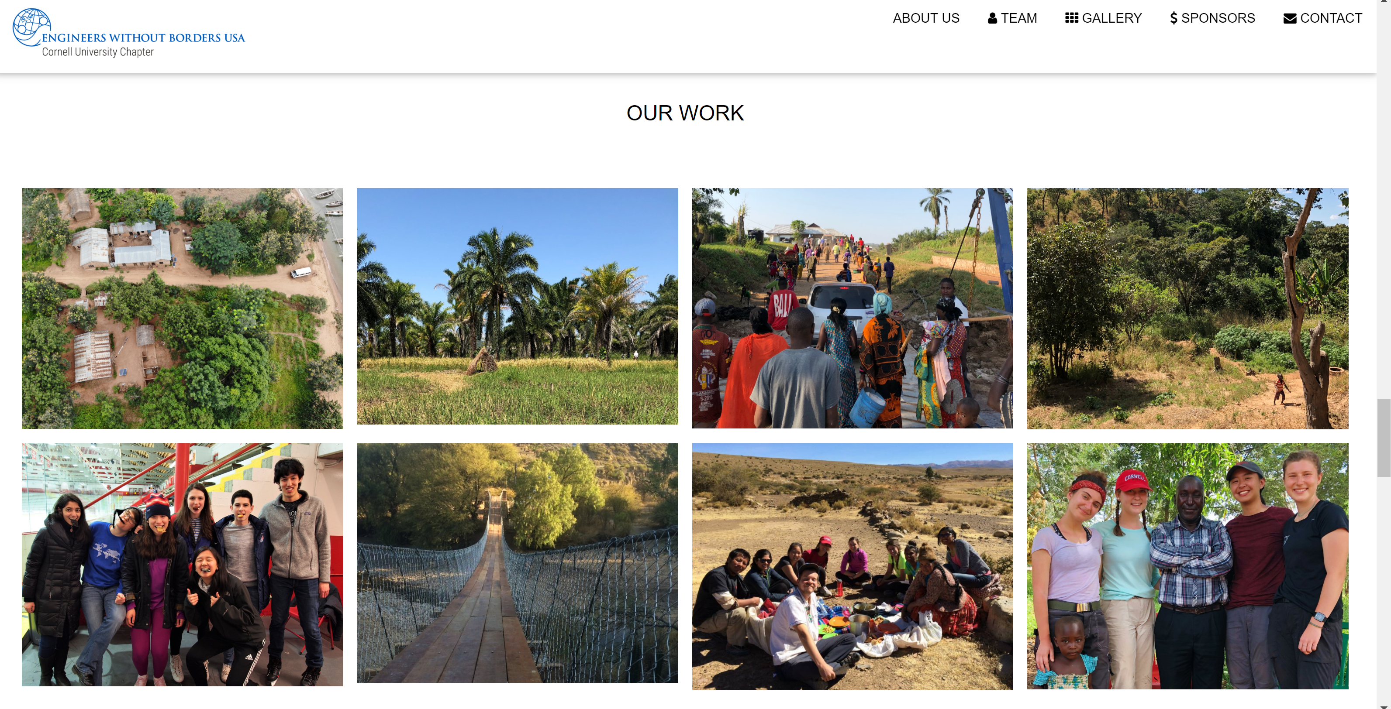

This image-heavy section of the website can easily be edited to change the images. Refer to the section under

<!-- Work Section -->

for this portion (linked with #work or by clicking the “GALLERY” button on the navbar). Here the edits will mainly be updating images by uploading new images to the folder and replacing them in the image tag. 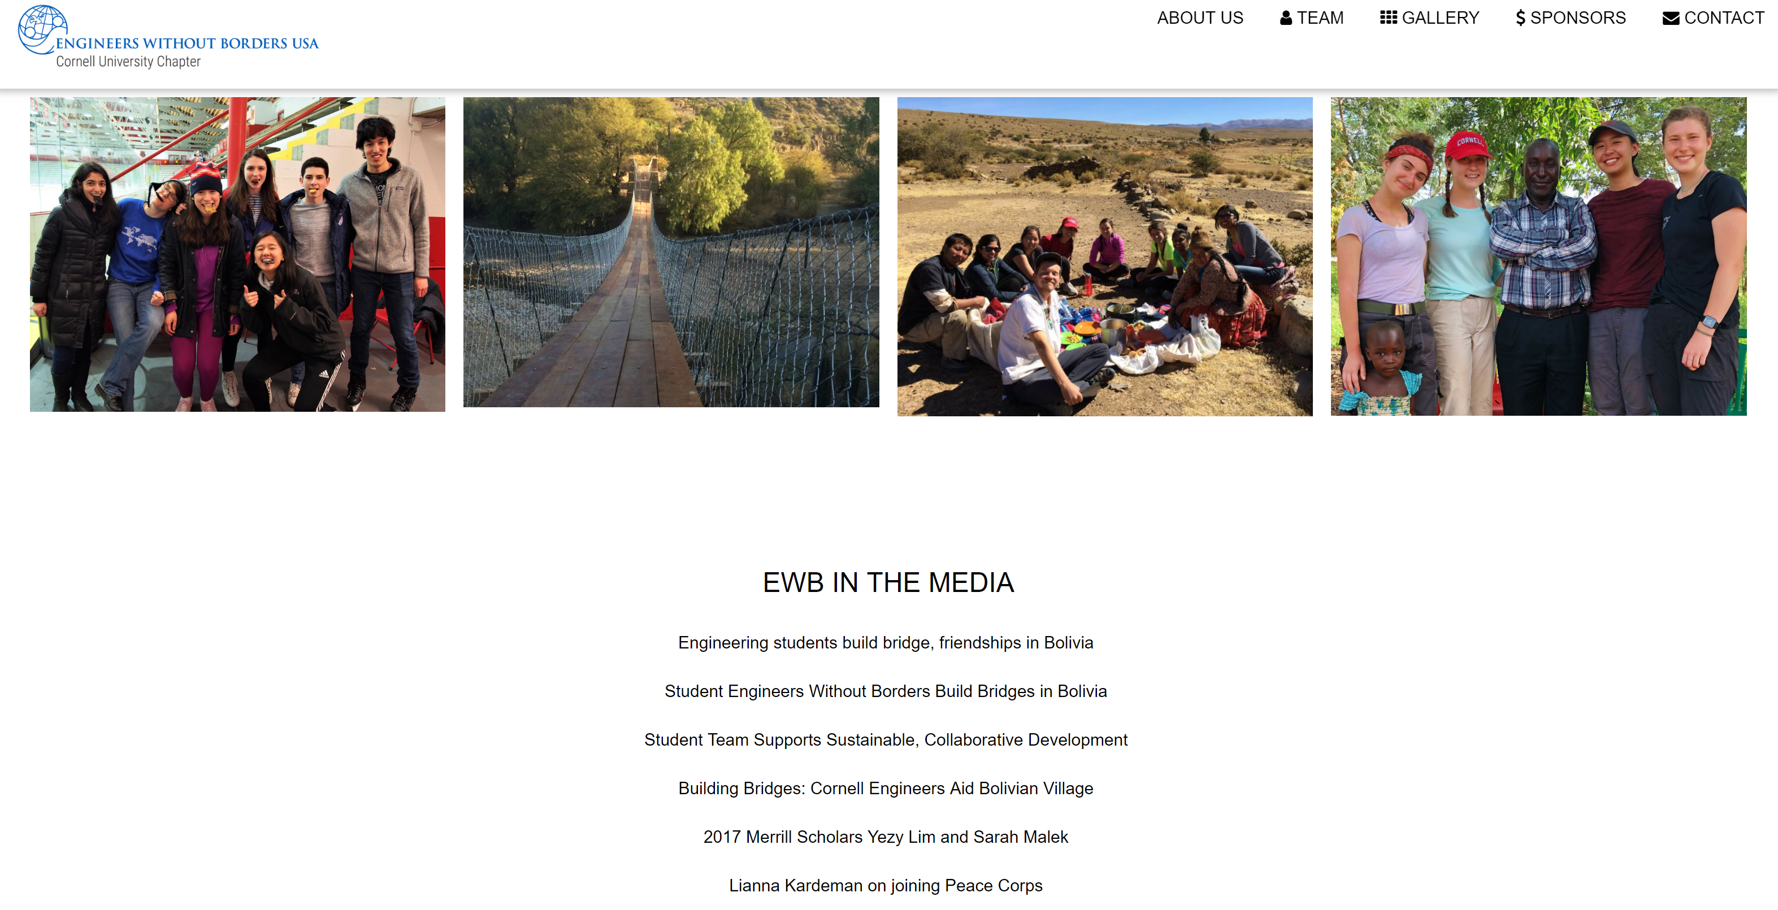

Also edited in this section is the media content, links to articles written about our team or members of our team. Simply by copying the a tag and adding a new link and title you can add more media as it arises.

**Sponsors**

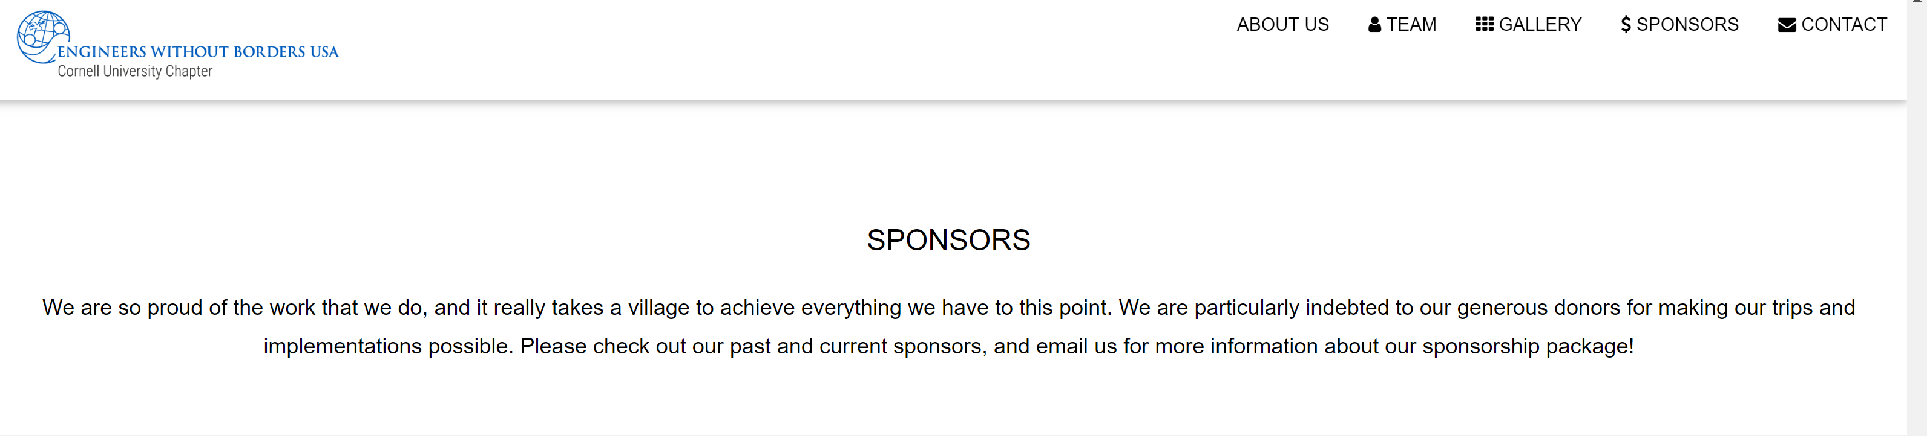

Currently very bare, the sponsors section under the comment

<!--Sponsors-->

should be updated with logos of companies and links to their websites. Additionally, indicate their status as a donor (gold, silver, etc) as dictated by the sponsorship packet.

**Contact**

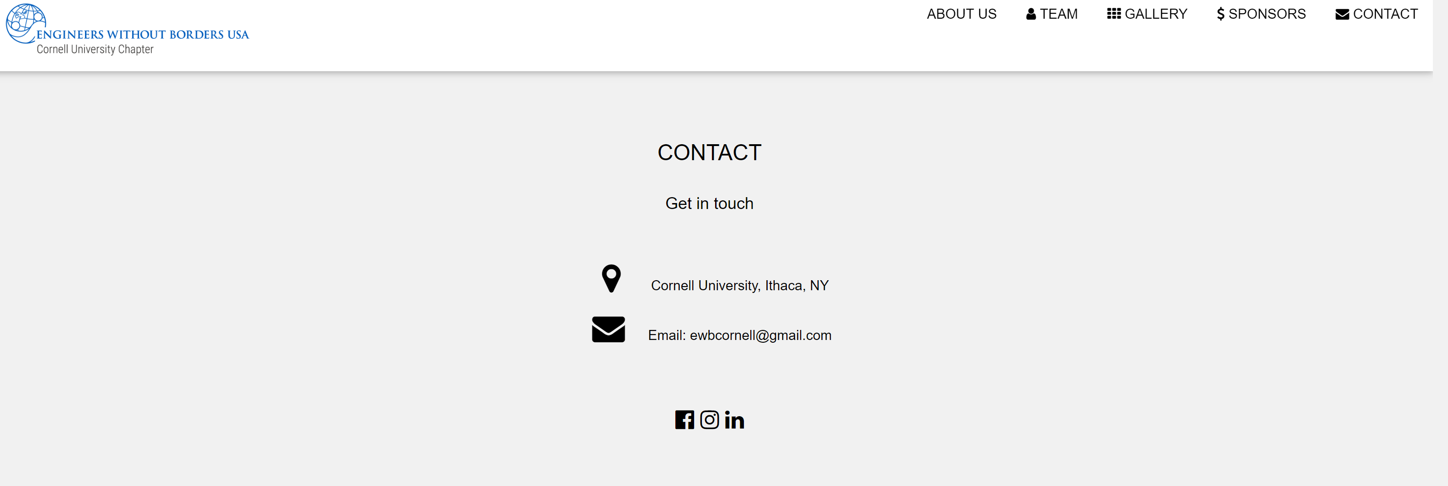

This section under

<!-- Contact Section -->

and linked by

#contact

or by the CONTACT button on the navbar is unlikely to need to be edited. It should contain all ways of contacting EWB-Cornell, as well as links to social media (more forms can be linked with icons taken from the icon library linked above)

**Footer**

The website has a footer, which brings the reader back to the top of the website.

**TO-DOS!:**

* Each semester, update the sponsors information as needed. Sponsors will not appreciate being left off the website for long.
* Edit text in promo sections and about us to reflect any changes or advancements in the project (easily changing the text)
* Edit any images to highlight new images, being sure to save and archive any images you are removing!
* As needed, add any new media links to highlight our team!
* Most importantly, the most frequent change to the website will be the TEAM portion, which will change every year (or semester depending on recruitment cycle).
  + Refer to the code explained above to add new members and remove old members from each subteam
  + Highlight the new team picture, and move the old image down with the other old team pictures. The images should have the same dimensions for best-looking website.
  + This process is not technically difficult but can become tedious because of the time needed to hardcode each member’s section and download their image and look up their net id, so begin quickly after the team photo has been taken to ensure the website is current.

**Server INFO**

Refer to the document media001 also in this folder for instructions on publishing our website to the server.